Table of Contents

About Circuits1

Electric Office circuit model objects2

Circuit2

Circuit Source5

Circuit Stopper 5

Circuit Section5

Circuit Building6

Troubleshooting6

Sectionalizing circuits6

Isolatable sections7

Circuit source sections7

Rebuilding circuits and circuit sections7

Meshed networks8

Spot networks8

Grid networks11

At Smallworld Electric Office version 4.2, the flexible circuit data model was introduced. This circuit model is compatible with the generalised conducting model.

The circuit model is the underlying data model that Electric Office uses for the creation and management of circuits. This model supports circuit building, the creation of isolatable circuit sections and the modelling of meshed networks.

About Circuits

A circuit is a set of electrically connected conducting equipment and supporting structures and is the fundamental logical object for network management in an electric utility. Circuits can be either Transmission (HV) or Distribution (MV/LV) circuits, also known as feeders, or substation circuits (HV/MV/LV), also known as bays.

Transmission circuits are sets of conductors energized at transmission level (typically more than 69,000V) that transmit large blocks of electrical energy over large distances. Transmission circuits link power generators to the distribution network via transmission substations. Transmission circuits may be overhead, with structures supporting conductors attached to insulators; or underground, with conductors surrounded by insulation and shielding.

Distribution circuits originate in a distribution substation and include the conductors and equipment necessary to distribute electricity to a customer. Distribution circuits can be either distribution feeder circuits (commonly distribution main-feeder circuits or express feeder circuits) or primary circuits, and generally operate at voltages between 2,400 and 34,500 volts.

Distribution feeder circuits typically originate at the terminals of a circuit breaker or recloser in a distribution substation. Generally, they leave the terminals underground on substation exit cables that are connected to overhead distribution feeders near the substation.

The distribution feeder circuits serve as a source to the primary distribution circuits (also known as branch circuits) which are connected to the overhead feeders. From any one substation there may be multiple distribution feeder circuits feeding multiple primary distribution circuits.

The primary distribution circuit is comprised of a central higher voltage load-carrying backbone circuit and lower voltage branch circuits that carry power from the backbone to house connection distribution transformers. A distribution transformer is installed in the vicinity of each customer and reduces the primary circuit voltage to utilisation level, normally 120- or 240-volts single phase for residential service and 120 or 277 volts three phase for commercial or industrial use.

Downstream from the connection distribution transformer is known as the secondary circuit, these are low voltage circuits primarily used for street lighting and house connections.

Electric Office circuit model objects

Circuit

The Circuit object represents a logical grouping of electrically connected network objects.

A circuit begins at one or more circuit sources that represent points from which the circuit is fed (see [Circuit Source](https://smallworld.gedigitalenergy.com/docs/sw52/en/Subsystems/ElectricOffice/Content/ElectricOfficeDataModelRef/CircuitsInEO.htm#eodatamodelcircuits_1869786479_1008977)) and ends at circuit boundary objects. A circuit boundary object can be:

an open Isolating Equipment Installation, such as a switch or circuit breaker

any electrical object which has been designated as a Circuit Source

objects identified as Circuit Stoppers (see [Circuit Stopper](https://smallworld.gedigitalenergy.com/docs/sw52/en/Subsystems/ElectricOffice/Content/ElectricOfficeDataModelRef/CircuitsInEO.htm#eodatamodelcircuits_1869786479_1008985)).

When a circuit is built, a Circuit Extent object is created. This object stores a circuit extent geometry which is displayed in the view as a buffer drawn around the objects that are part of the circuit. Circuit extents are created by default, but the configuration can be changed to suppress circuit extent creation.

As the circuit build routine traces out from the circuit source(s), the objects encountered by the trace are associated with the circuit object via join fields. For example:

Equipment—all electric objects in the circuit, including isolating equipment, power transformers, energy sources and so on.

Line Segments—all conductors in the circuit, for example cable segments and wire segments.

Structures—all structures, such as poles, that support the electrical objects and conductors.

A circuit object also has join fields identifying the originating substation(s) and any adjoining circuits, upstream and downstream.

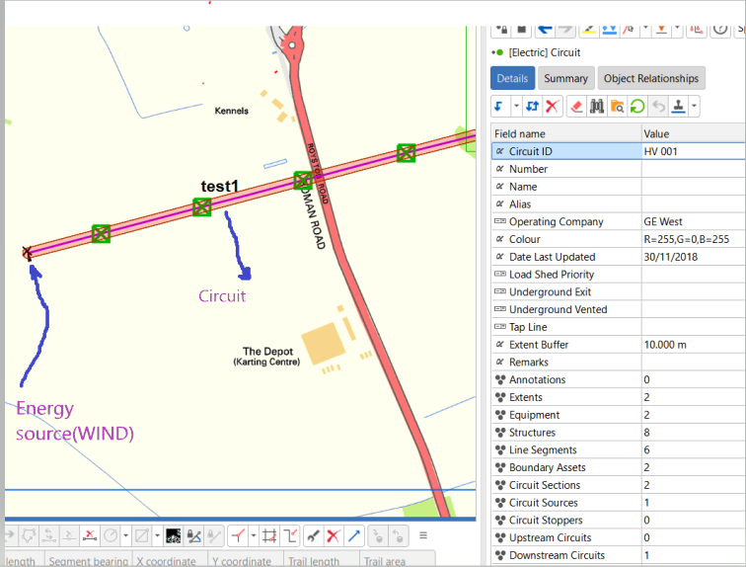

**Fig(1)**

In the above Fig(1). From Energy Source (**Wind**-which starting of electrical network) to next substation, Circuit (Circuit ID: HV 001) is builded through Line Segments (Wire Segment), Structures (Tower or Pole), Equipment’s (trfmrs, circuit breakers) etc.

The circuit is builded through all the objects, which are covered in tracing ( running Electric Trace).in this circuit Energy Source acts as Circuit Source and transformer primary in substation acts as Circuit Stopper.

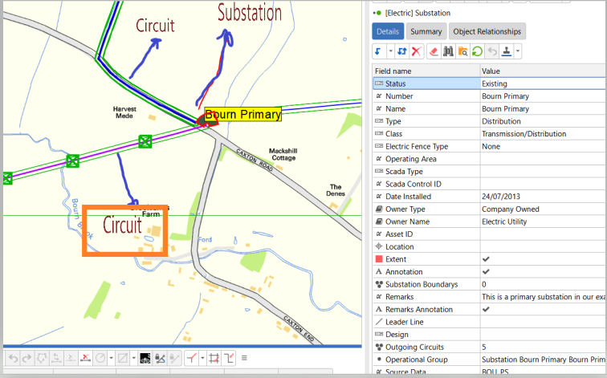

**Fig(2)**

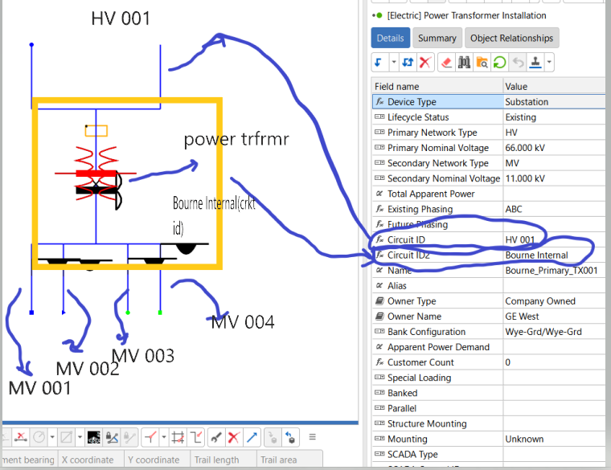

**Fig(3)**

In the above Fig(3). it is an internal world of substation (Which contains power transformer, connector segments, Circuit breakers)

Here one circuit (Circuit ID-HV 001) builded from Energy Source (Wind) to Primary side of power transformer and another circuit(Circuit ID- Bourne Internal) builded from secondary side of transformer to circuit breakers. these two Circuit ID’s are updated in Circuit ID, Circuit ID2 fields of transformer which is shown in Fig.

From each circuit breaker other end to another substation or opened circuit breaker new circuits are builded (as MV 001, MV 002, MV003 and MV 004) which is shown in fig.

Circuit Source

Circuit Source objects identify the object(s) from which a circuit is fed. A single circuit can have multiple sources. In a meshed network, multiple circuit sources can be used to feed a single circuit or multiple circuits. Circuit source objects have simple point geometries.

A circuit source can exist in the geographic world, such as a solar energy source (Energy Source with device type Solar), or in an internal world, such as a circuit breaker inside a substation (Isolating Equipment Installation with device type Circuit Breaker).

The Circuit Source object has join fields identifying the particular object acting as the source, and the circuit (Circuit ID) with which it is associated.

Circuit Stopper

A Circuit Stopper identifies an object that behaves as a circuit boundary object. To limit the extent of a circuit, the user can identify a particular piece of equipment as a stopper: the circuit building trace stops when it encounters a circuit stopper. Circuit stoppers are additional to the general boundary objects such as open switches.

In a meshed network, a circuit stopper can denote a point at which the network should be split into two logical sub-circuits.

Circuit Section

Circuit Sections are logical sub-units of a circuit. The boundaries of circuit sections are defined by the position of sectionalizing objects, such as Isolating Equipment Installations, and internal boundary objects on the parent circuit.

Circuit sections can also be associated with a Circuit Section Extent object that stores an extent geometry that is drawn in the view to identify circuit sections. Creation of circuit section extents is optional.

The Circuit Section object has joins to Equipment, Line Segments and Structures similar to those for the circuit object.

[Circuit building](javascript:void(0);)

Once a user has created a circuit object and identified a circuit source or sources, they can build the circuit using the Circuit Builder dialog box available from the Circuit editor and Circuit Source editor.

The circuit build routine starts at the circuit source object(s) and traces downstream through all of the conducting equipment that is fed by the source(s). Because the circuit source is a logical object and does not connect topologically with the network, circuit tracing actually starts at the object associated with the circuit source, such as an Isolating Equipment Installation inside a substation.

Joins are created between the circuit and all equipment, structures and line segments that are found in the trace. If the creation of circuit extents is enabled, a circuit extent is created and joined to the parent circuit.

The trace stops at circuit boundary objects, such as other circuit sources and open switches, as well as any circuit stopper objects that the user has defined. The circuit build also creates joins between the circuit and circuit stoppers and boundary objects.

The circuit build process additionally identifies any topologically connected upstream or downstream circuits connected to the circuit being built, and creates joins on the Upstream Circuit and Downstream Circuit join fields. If the Circuit Source object was associated with an object inside a substation, the circuit build records this in the Originating Substation join.

Troubleshooting

Circuit building relies on the underlying network components, such as Wire Segments, Isolating Equipment Installations and Power Transformer Installations being properly connected electrically.

If circuit building fails or appears to be taking too long, you should check that:

The connectivity of the underlying network, such as Isolating Equipment Installations, is correct. For example, if the Isolating Equipment Installation is open, you could use the Electric Trace tool to verify that the trace stops at this open Isolating Equipment Installation.

Circuit Source objects have the correct flow direction so that the circuit builds in that direction, for example the source and load locations of Power Transformer Installations must be correctly placed on the appropriate conductors.use the Electric Trace tool or quality routines to identify any further problems.

[Sectionalizing circuits](javascript:void(0);)

Circuit sections are logical sub-units of a circuit, with boundaries defined by sectionalizing objects and internal boundary objects along the parent circuit. In Electric Office, two types of circuit section are available as standard—isolatable sections and circuit source sections.

Isolatable sections

Isolatable sections are created between isolating equipment objects in the network that have been defined as sectionalizing objects.The boundaries of isolatable sections can be defined according to the equipment type and one of its attributes, for instance, you could define circuit sections that are sectionalized only where the equipment type is a switch which has the status Open. Multiple isolating equipment object types can be defined as sectionalizing objects, a circuit can for example be sectionalized by switches, reclosers, circuit breakers or any other type of isolating equipment.

When a user runs the Circuit Builder, they can choose whether or not to create isolatable sections. These sections are built once the circuit build process has been executed. The isolatable section build performs a downstream trace from the Circuit Source object(s) through all the downstream network objects in the circuit. The routine creates new sections between all the objects that have been predefined as sectionalizing objects.

As for the Circuit object, Circuit Sections have joins to Equipment, Line Segments and Structures that are populated with objects associated with that section. The parent circuit is identified by its Circuit ID.

Circuit source sections

Circuit source sections are used to subdivide a circuit that has multiple sources of feed so that it is possible to identify which circuit source an object is fed from. Circuit source sections are built where a section of network between two or more circuit sources is subdivided by internal boundary objects: these internal boundaries can be represented by circuit stopper objects or objects that have been preconfigured as boundary objects.

When the user runs the Circuit Builder, they can choose whether or not to create circuit source sections. These sections are built once the circuit build process has been executed.

The circuit source sectioning trace starts from a circuit source and traces all of the electrically connected objects (including the objects that act as circuit sources of the same circuit) up to the internal boundaries of the circuit: a circuit source section object is created for this portion of network and joined to the associated assets. Next the circuit source sectioning starts from one of the remaining circuit sources which was not encountered during the first trace and another circuit source section is formed. This continues until all the circuit source objects are traced.

[Rebuilding circuits and circuit sections](javascript:void(0);)

The circuit and circuit section rebuild process follows the same workflow as building the circuit or circuit section but the following rules are applied.

These objects are included in the rebuilt circuit:

* All objects currently joined to the parent circuit maintain their existing join if they are still topologically connected to the circuit (and if they have not been changed to meet the criteria defined for boundary objects).
* All objects that have been newly added and are now topologically connected to the network (for example, if a new lateral has been added) have a join created.

These objects are removed from the rebuilt circuit (the circuit join is removed):

* Objects removed from the network (for example, if a lateral has been removed).
* Objects that are now downstream of new boundary objects.
* Objects that are no longer part of the current view of the network because their lifecycle status has been changed.
* Objects that are part of the existing network but where there is now an intervening portion of network between the object and the circuit source that is no longer current.

[Meshed networks](javascript:void(0);)

Meshed electrical networks are created in such a way that if the connectivity of the network is broken in one place it is possible to maintain electrical connectivity with an alternative energy source or sources. Meshed networks are created on LV networks fed by multiple secondary transformer energy sources, predominantly in urban areas where the need for a consistent energy supply is high.

Spot networks and grid networks are two different kinds of meshed network. A spot network supplies the secondary network and has all of the supply transformers arranged on the secondary side at one location. A grid network is an LV network with geographically separated network units (MV/LV transformers, LV circuit breakers and so on) interconnected by LV line segments.

Electric Office provides a range of support for the creation and management of meshed networks which use the circuit source and stopper objects to subdivide networks into meshed sections. The following scenarios describe different meshed network configurations that can be found in MV/LV networks.

[Spot networks](javascript:void(0);)

In this example, three internal MV circuit breakers (CB1, CB2, CB3) are the circuit sources for three separate radial circuits ending at the MV source side of transformers 1, 2 and 3. The load side of each of the transformers is the circuit source for a single LV network: these transformers are therefore circuit ties between the MV and LV circuits, that is, they are associated with both circuits.

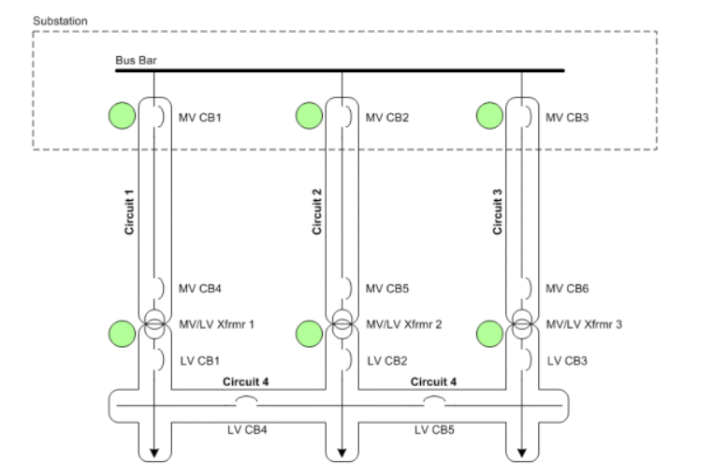

To create this network in Electric Office, the user first creates four circuit objects—circuits 1, 2, 3 and 4. An association is then created between the circuit source objects for each circuit and the circuit object itself: in this instance the CB1 object is associated as the circuit source for circuit 1, CB2 as the source asset for circuit 2 and CB3 as the source asset for circuit 3. Transformers 1, 2 and 3 are associated as the circuit sources for circuit 4 (circuit 4 is therefore a single circuit with multiple circuit sources).

When you build Circuit 1, a single radial circuit is built between circuit breaker CB1 and the downstream source side of transformer Xfrmr1. Circuits 2 and 3 are built in the same way. Circuit 4 is built downstream of the load side of the three transformers: transformers Xfrmr1, Xfrmr2 and Xfrmr3 are therefore circuit ties between the upstream and downstream circuits and are associated with both circuits via the Circuit ID and Circuit ID2 fields. The Downstream Circuits field for Circuits 1, 2 and 3 lists Circuit 4 as an associated object: likewise, the Upstream Circuits field for Circuit 4 lists Circuits 1, 2 and 3.

Meshed networks can be partitioned using different configurations of circuit source and stopper objects. In this example, a circuit stopper object has been placed on LV circuit breaker CB4, and LV CB1, CB2 and CB3 are all sources for Circuit 4: this means that the circuit stopper at LV CB4 is an internal boundary, that is, a boundary object that lies between two circuit sources on the same circuit. When the circuit is built, a single circuit is created and an association is created between the circuit and the stopper object.

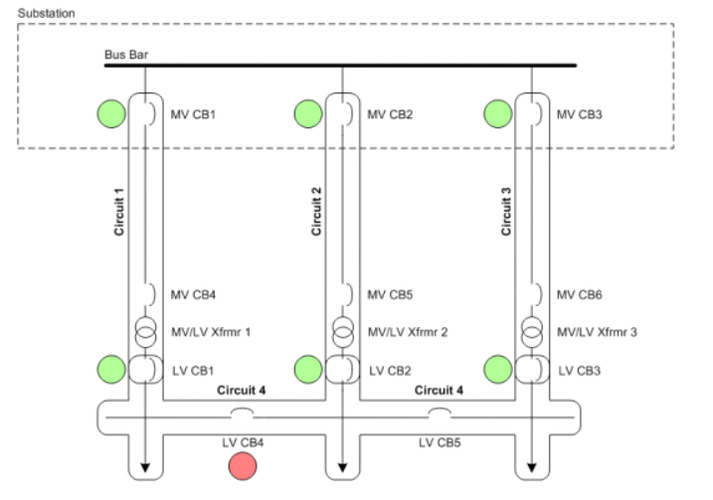

If you build circuit source sections for Circuit 4 the placement of the internal boundary stopper object at LV CB4 subdivides the circuit into two circuit source sections:

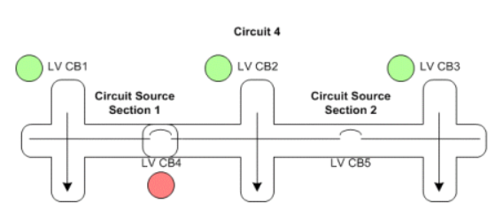

If you specify that LV CB1 is a feeder of circuit 4, and that LV CB2 and CB3 are the feeders for a different circuit 5, placing a stopper object at LV CB4 creates a circuit boundary object rather than an internal boundary and splits the two circuits when Circuits 4 and 5 are built. In this instance LV CB4 also becomes a circuit tie between Circuits 4 and 5.

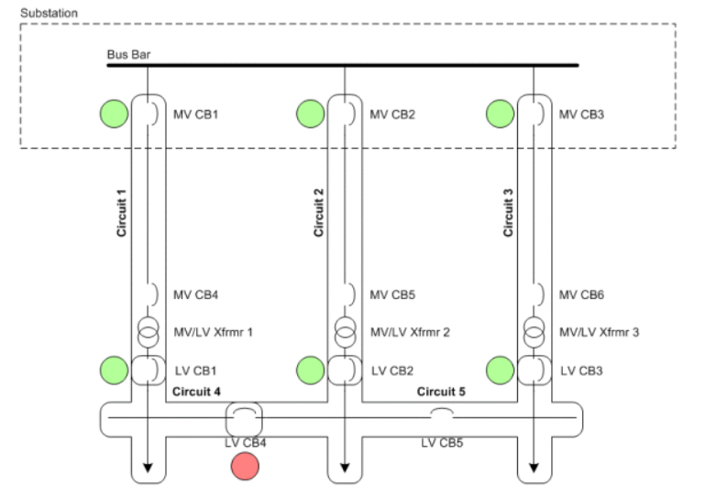

[Grid networks](javascript:void(0);)

In a meshed grid network, circuit sources and stoppers can be used to subdivide the meshed partitions of the network.

In this example, transformers 1, 2, 3 and 4 are circuit sources for a single LV meshed network. When the circuit is built, all traceable elements from each circuit source object, including energy consumers and demand points, are associated with the circuit. No circuit source sections can be created for this circuit as the circuit is not partitioned by any internal boundary objects.

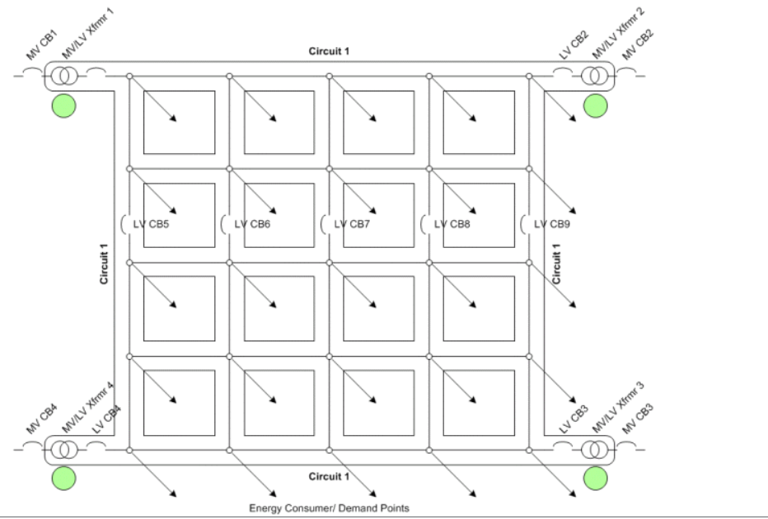

Now, LV circuit breakers CB5 to CB9 have been specified as circuit stopper objects. In this case these objects are internal boundary objects that make no difference to the overall circuit build. If you choose to build circuit source sections, two circuit source sections are created: one on each side of the internal boundary.

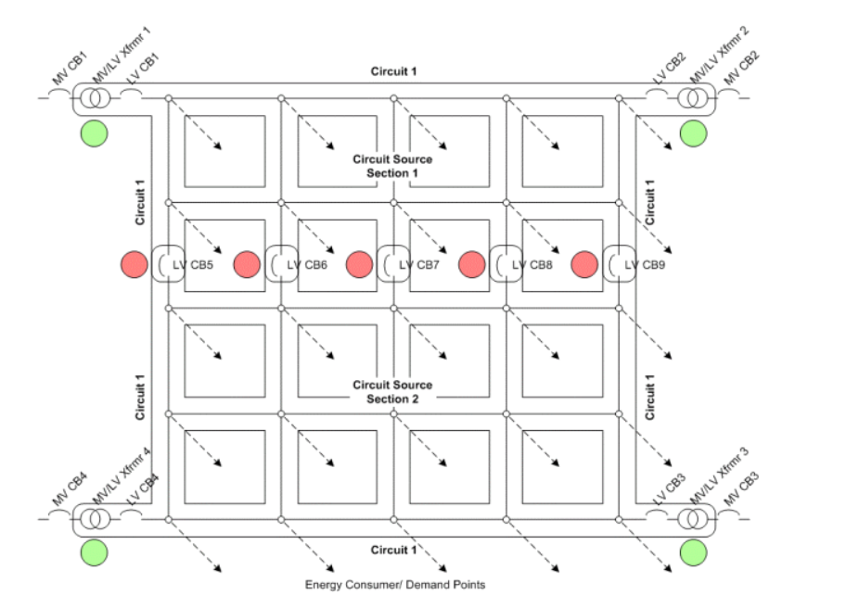

In this example, transformers 1 and 2 are circuit sources for circuit 1, and transformers 3 and 4 are circuit sources for circuit 2. LV circuit breakers CB5 to CB9 have been specified as circuit stoppers and are circuit boundary objects between Circuits 1 and 2. In this case, you build two circuits—Circuit 1 and Circuit 2— on either side of the boundary objects. LV circuit breakers CB5 to CB9 are circuit ties between Circuit 1 and Circuit 2 and are associated with both circuits via their Circuit ID and Circuit ID2 fields.

